21st Century Skills

Two NEET aspirants died by suicide in Rajasthan's Kota hours after taking a test on Sunday. Twenty-four students have died by suicide in Kota this year.

This news made me upset and forced me to think about the relevance of education in real life. Education should not just be limited to the textbook but should cater to intellectual, emotional, personal, and social needs.

According to Gandhiji literacy itself is no education. Literacy is just a means of education. He emphasized the development of the head, heart, and hand (3 H). According to Gandhiji “true education is that which draws out and stimulates the spiritual, intellectual, and physical faculties of the children.

In our country, the education system is influenced by Macaulay. In the British Raj, the only motive of education was to grow an educated servant class (followers). Sadly, after 75 years of independence, our nation is lacking good leaders in every field. Why any Indian without going abroad able to win any award for literature, science, research, or another field? The Indian education system just become a degree producer to fulfil the international goals (EFA and MDG).
Our education system has seen many changes and reformation but till now we are not able to give quality education to our young generation to grow as confident and visionary leaders. This is an era of knowledge society. The rate of enrolments is generally very high at almost all levels- primary, secondary, and tertiary and even adult learners assume a greater presence on campuses. Educational institutions are filled with disquiet. The emergence of the 'education industry', acceleration of online learning, 'corporate universities, and growing numbers of new certificates and degrees all seem to signify that we are in a moment of transformational change. But unfortunately, leadership is not being implemented as per the requirement. As a result, our country is lagging far behind in many aspects in comparison to its many counterparts though we have the third-largest higher education system in the country after the US and China. India ranks at 124 out of 173 countries in the Human Development Index.
As Scott mentioned in his study “THE FUTURE OF LEARNING 2: WHAT KIND OF LEARNING FOR THE 21st CENTURY?” “Growing concern about potential economic and global crises ahead is leading many to question whether today’s learners possess the combination of critical thinking, creativity, and collaborative and communication skills necessary to tackle the unexpected developments they will face. This paper explores these skills in-depth and highlights several key elements for learning in the twenty-first century including personalization, collaboration, communication, informal learning, productivity, and content creation. It also underlines the importance to the twenty-first-century workplace of personal skills such as initiative, resilience, responsibility, risk-taking, and creativity; social skills such as teamwork, networking, empathy, and compassion; and learning skills such as managing, and organizing, meta-cognitive skills, and ‘failing forward’” (Scott, 2015).

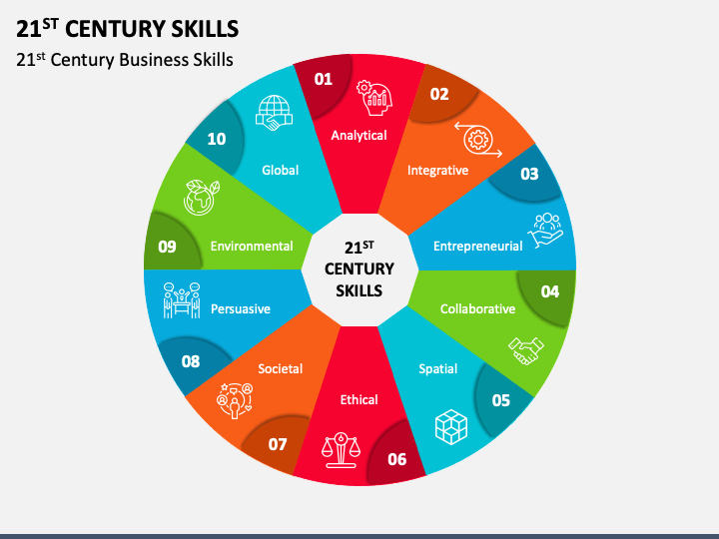

The glossary of education reform defines 21st-century skills as “a broad set of knowledge, skills, work habits, and character traits that are believed … to be critically important to success in today’s world, particularly in collegiate programs and contemporary careers and workplaces.

“There are three key 21st-century skills i.e., Learning Skills, Literacy Skills, and Life Skills.

Life skills include:

● Flexibility
● Leadership
● Initiative
● Productivity,
● Self-awareness

Personalization, collaboration, communication, informal learning, productivity, and content creation are central to the competencies and skills learners are expected to develop and how these skills are taught. These elements are key to the overall vision of twenty-first-century learning. In addition, personal skills (initiative, resilience, responsibility, risk-taking, and creativity), social skills (teamwork, networking, empathy, and compassion, and learning skills (managing, organizing, meta-cognitive skills, and ‘failing for twenty-first-century one of and response to failure) are vital to peak performance in the twenty-first-century workplace.

The aim of education is not just to let learners obtain basic knowledge but to make them lifelong learners. It is to nurture future citizens who are mentally and physically robust assertive, confident, empathetic, helpful to the community, intellectually inquisitive and reflective, tolerant, and with creative vision and global perspective. To achieve this, we must guide our learners to achieve the following curriculum goals:

● To enhance self-awareness and explore innate potential;
● To develop creativity and the ability to appreciate art and showcase one’s talents;
● To promote capabilities related to goal setting, decision making, and lifelong learning;
● To nurture assertive communication and interpersonal skills;
● To learn to be empathetic towards others, display dignity and respect for the opposite gender,
● To strengthen knowledge and attitude related to livelihood skills;
● To develop abilities related to thinking skills and problem-solving.

The world is changing. The global economy, with its emerging industries and occupations, offers tremendous opportunities for everyone who has the skills to take advantage of it. Doing well in school no longer guarantees a lifelong job or a single career. Today, only people who have the knowledge and skills to negotiate constant change and reinvent themselves for new situations will succeed. Competency in 21st-century skills gives people the ability to keep learning and adjusting to change.

Jaya Dembla

